Dispatch

## +Add:

Dispatch>+Add will take to you to open a new dispatch. You can also reach there by Dispatch> Board>Add a New Dispatch.

The usual fields to create a dispatch are below. However, we realize that each customer has their administrative setup and requirements based on their clientele and offers customization to suit their organization's needs.

Fill in the field and save it.

## Board:

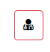This symbol notified if the operators called for this dispatch.

This symbol informs if the drivers called for this dispatch.

If you click on this sign, it will take you to the detail page of the specific dispatch information:

**Filtering data from Dispatch Board:**

You can drag and drop a column to create a filtered view, i.e, if you want to segment the dispatch log by Supervisors, you can drag the supervisor column to the filter bar, and you will get the list of the dispatched that took place under each supervisor. See the video below.

[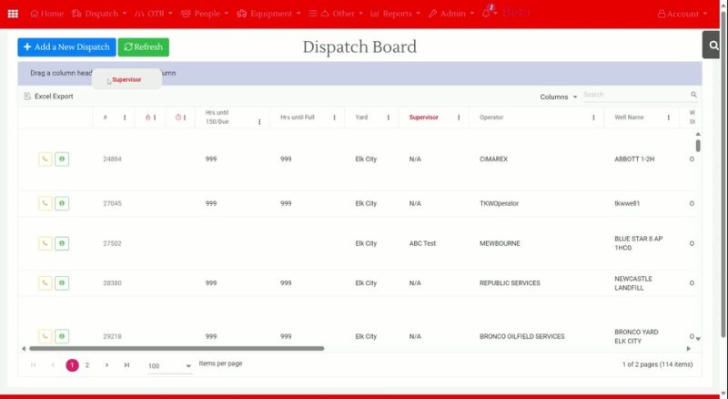](https://tkw1-my.sharepoint.com/:v:/p/shajia_khan/EVHqaqbCyeRBlwNaXry4WHABSrrnIM0y2G_6yoafBammoA?e=20UUyL&nav=eyJyZWZlcnJhbEluZm8iOnsicmVmZXJyYWxBcHAiOiJTdHJlYW1XZWJBcHAiLCJyZWZlcnJhbFZpZXciOiJTaGFyZURpYWxvZyIsInJlZmVycmFsQXBwUGxhdGZvcm0iOiJXZWIiLCJyZWZlcnJhbE1vZGUiOiJ2aWV3In19)

Pending:

Penidng tab contains list of dispatch orders that has been created ( usually through app) but has not been executed yet.

You can also see the number of pending disptchers from the Bell Icon of the top ribbon:

History:

List of Dispatch and History

App History:

List of dispatch added through App.

Voided:

List of Voided Dispatch.