People:

You can add/edit, or delete People from your application through this tab.

[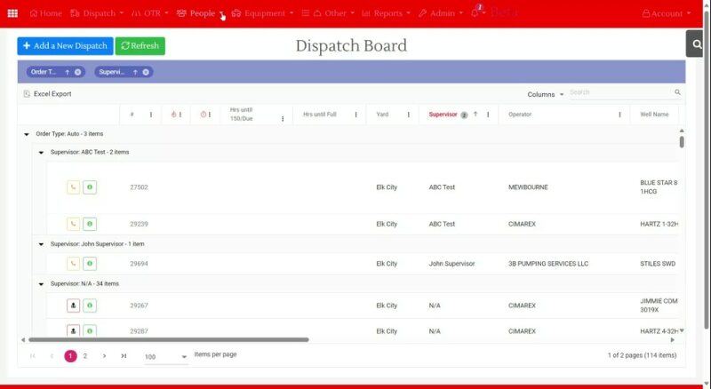](https://tkw1-my.sharepoint.com/:v:/p/shajia_khan/EV5uXF4eXepBm_2f3HVNKIcBcbKXM2WFuBV9kJMDtT4acw?e=uUfGgd&nav=eyJyZWZlcnJhbEluZm8iOnsicmVmZXJyYWxBcHAiOiJTdHJlYW1XZWJBcHAiLCJyZWZlcnJhbFZpZXciOiJTaGFyZURpYWxvZyIsInJlZmVycmFsQXBwUGxhdGZvcm0iOiJXZWIiLCJyZWZlcnJhbE1vZGUiOiJ2aWV3In19)

# Driver:

## Driver’s List:

You can see the current and archived drivers list from the Driver’s List.

Use the search function if you are looking for a particular driver.

Besides each driver’s name, some icons have their own functionality.

### Information About the Driver:

 You will know the specific driver details information if you click this icon.

Click each + sign to know more. For example, Dispatch history will show you the list of dispatch orders completed by the driver in the past.

You can also use the search box to find a particular order:

# Operators:

You can see the list of the Operators or Accounts and add each Account's representative (Company Man) to the company.

# Dispatcher:

## Dispatcher’s List:

It will show the list of dispatchers, and by clicking on the icons beside each dispatcher, you will be able to see the details of the dispatcher, edit the details, change his login, or delete him.

